# Worksheet 5 JavaScript

Activity 1:

1. Copy the **Tully Monster.html** file and **TullyMonster.png** to your own file area.
2. Open **Tully Monster.html** in a browser. Click on the button labelled ‘Show answer’ – what happens?
3. Open the same file in a text editor such as Notepad or in a web page editing program such as Dreamweaver.
4. Add another paragraph at the end of the <form>. It should say: “Click below to find out where it lived.” with the id ‘**box2**’.
5. Add a new button to your web page to display the answer “It lived in the tropical estuaries of Illinois, USA.”. You can use similar code to the first question.

Include the code:

<p id="box2">Click below to find out where it lived.</p>

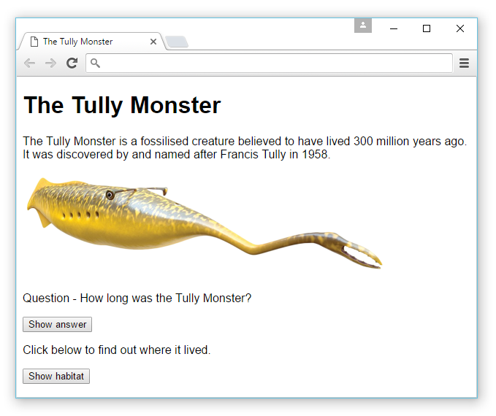

1. Test the new button.

Activity 2: Input and output

1. Using the same HTML file, add an input box to accept an answer to the question.

Answer: <input type="text" name="answer">

1. Save your HTML file and test your changes in a browser. You will notice that at this point, any user input is ignored when the button is clicked.

C:\Users\Rob\AppData\Roaming\PixelMetrics\CaptureWiz\Temp\66.png

**Validating use input with a JavaScript function**

1. Insert <script> tags at the end of HTML file before the closing </body> tag.

<script> </script>

1. Insert a new function called validate within the <script> tags using the code below:

**function** validate**()** **{**

**var** x = document.forms["question"]["answer"].value;

**if** **(**x == ""**) {**

document.getElementById**(**"box"**)**.style.color="red";

**}**

**}**

This will later turn the question text red if the answer is left blank.

1. Change the button onclick action to execute the function:

<button type="button" **onclick="validate()"**>Show answer</button>

1. **Save** the file and refresh the browser. Test the new function.
2. Add in an else if clause to the IF statement to output an alert box if the answer is correct.

**else if** **(**x == "35cm"**){**

alert**(**"Correct!"**)**;

**}**

1. **Save** the file and refresh the browser again. Test the alert function by entering the correct answer.

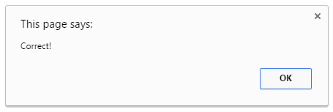

1. Amend your code using an additional function using the code below to show or hide the image. The function syntax is included below:

**function** showHide**() {**

**var** x = document.getElementById**(**"monster"**)**;

**if(**x.style.display == 'block'**)**

x.style.display = 'none';

**else**

x.style.display = 'block';

**}**

You will need to include a new <div> block around the image called “monster”, and a new button to call the function.

**Activity 3: Writing directly to an HTML document**

1. Insert the code: document.write("Goodbye World!"); just inside the opening <script> tag of your HTML document from Activity 2. What happens?
2. Include some HTML element tags within the write statement, for example: document.write("<h1>Goodbye World!</h1>");
3. Now move the same line of code inside a function. **Save** the file and execute the function by clicking on the button. What happens? Why?

**Activity 4: Using arrays with JavaScript**

1. Copy the file **DiceRoll.html** into your own file area.
2. Open **DiceRoll.html** in a browser. Click on the button labelled ‘Roll the dice’ – what happens?
3. Open the same file in a text editor such as Notepad or in a web page editing program such as Dreamweaver.
4. You will be able to see how the JavaScript code works, more specifically how the button calling the **rollDice()** function makes use of the **dice** array, alongside the behaviour of the button **‘Click Me!’**
5. You will see the following line of code in the rollDice() function, which chooses a random item in the array:

var roll = Math.ceil(Math.random() * dice.length);

